CA2-CAP777
My Expense Manager
Name: Prashant Patil
Roll no: 24
Reg No: 12527088
Group: 1
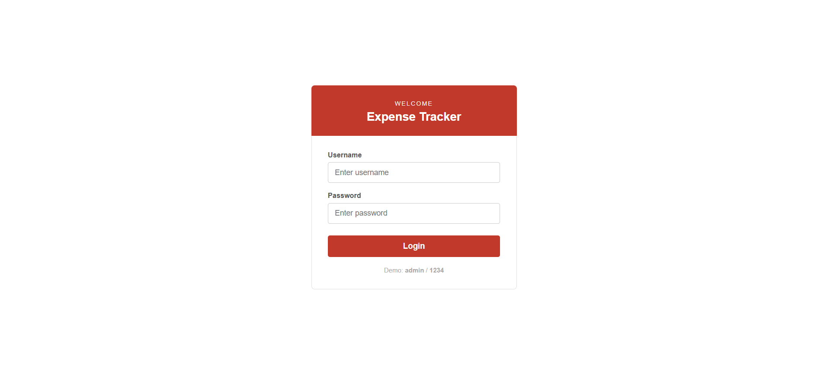
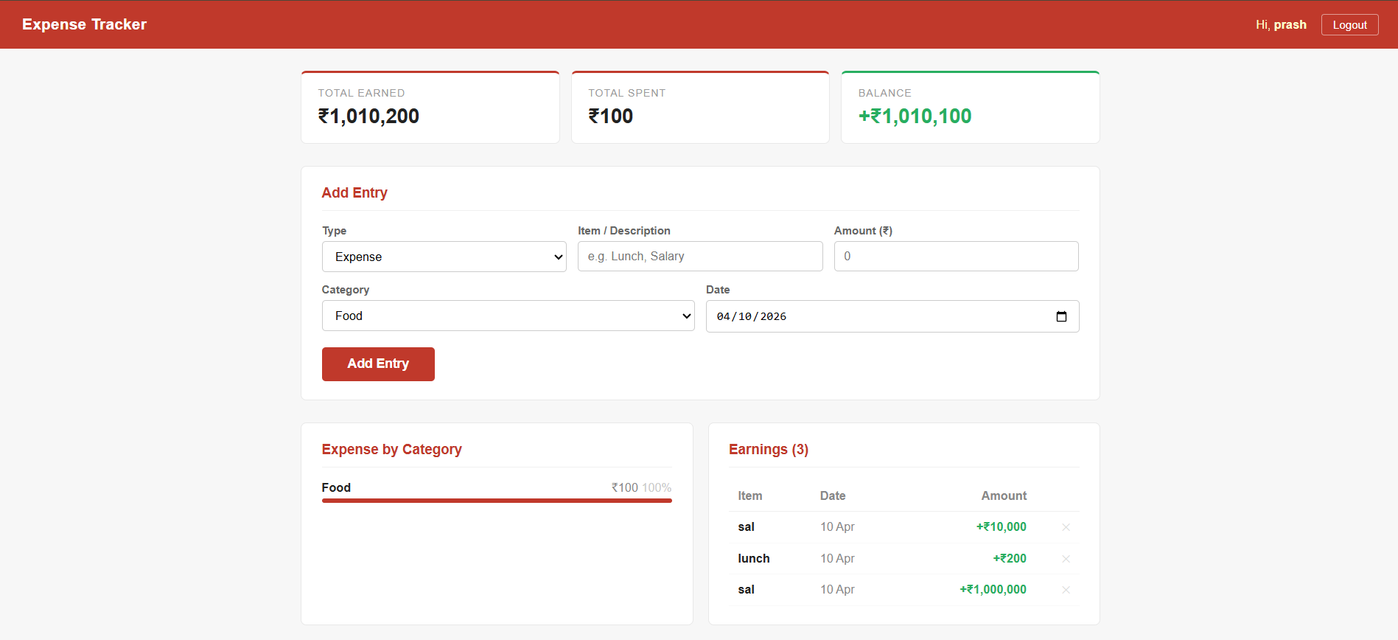

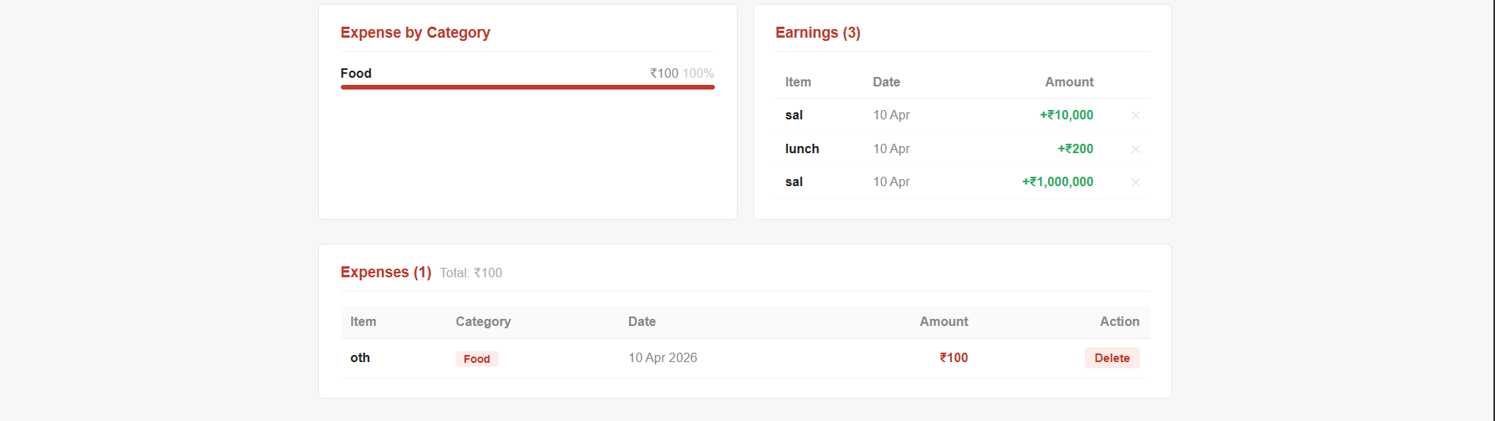

<?php
session_start();

if (isset($_SESSION['user'])) {
header('Location: index.php');
exit;
}

// Simple user store (array - Unit I: variables & arrays)
$users = [
'admin' => '1234',
'prash' => 'pass123',
'patil' => 'pass456'
];

$error = '';

// Unit IV: Handling HTML forms with PHP
if ($_SERVER['REQUEST_METHOD'] === 'POST') {
$username = trim($_POST['username'] ?? '');
$password = trim($_POST['password'] ?? '');

// Unit II: User defined functions
function validateLogin($users, $username, $password) {
if ($username === '') return 'Please enter username.';
if ($password === '') return 'Please enter password.';
if (!array_key_exists($username, $users)) return 'Username not found.';
if ($users[$username] !== $password) return 'Wrong password.';
return '';
}

$error = validateLogin($users, $username, $password);

if ($error === '') {
$_SESSION['user'] = $username;
header('Location: index.php');
exit;
}
}
?>
<!DOCTYPE html>
<html lang="en">
<head>
<meta charset="UTF-8">
<meta name="viewport" content="width=device-width, initial-scale=1.0">
<title>Login – Expense Tracker</title>
</head>
<body style="margin:0; padding:0; background:#fff; font-family:Arial, sans-serif; min-height:100vh; display:flex; align-items:center; justify-content:center;">

<div style="width:100%; max-width:380px; padding:16px;">

<!-- Header -->
<div style="background:#c0392b; padding:28px 30px 22px; border-radius:6px 6px 0 0; text-align:center;">
<p style="margin:0; color:#fff; font-size:11px; letter-spacing:2px; text-transform:uppercase;">Welcome</p>
<h1 style="margin:6px 0 0; color:#fff; font-size:22px; font-weight:700;">Expense Tracker</h1>
</div>

<!-- Form box -->
<div style="background:#fff; border:1px solid #e0e0e0; border-top:none; border-radius:0 0 6px 6px; padding:28px 30px;">

<?php if ($error !== ''): ?>
<div style="background:#fdecea; border-left:3px solid #c0392b; padding:10px 14px; margin-bottom:18px; border-radius:3px;">
<p style="margin:0; color:#c0392b; font-size:13px;"><?= htmlspecialchars($error) ?></p>
</div>
<?php endif; ?>

<!-- Unit IV: HTML form controls -->
<form method="POST">

<div style="margin-bottom:16px;">
<label style="display:block; font-size:13px; color:#555; margin-bottom:6px; font-weight:600;">Username</label>
<input type="text" name="username" value="<?= htmlspecialchars($_POST['username'] ?? '') ?>"
placeholder="Enter username"
style="width:100%; box-sizing:border-box; padding:10px 12px; border:1px solid #ccc; border-radius:4px; font-size:14px; outline:none;">
</div>

<div style="margin-bottom:22px;">
<label style="display:block; font-size:13px; color:#555; margin-bottom:6px; font-weight:600;">Password</label>
<input type="password" name="password"
placeholder="Enter password"
style="width:100%; box-sizing:border-box; padding:10px 12px; border:1px solid #ccc; border-radius:4px; font-size:14px; outline:none;">
</div>

<button type="submit"
style="width:100%; padding:11px; background:#c0392b; color:#fff; border:none; border-radius:4px; font-size:15px; font-weight:600; cursor:pointer;">
Login
</button>

</form>

<p style="margin:18px 0 0; font-size:12px; color:#aaa; text-align:center;">
Demo: <strong>admin</strong> / <strong>1234</strong>
</p>
</div>

</div>
</body>
</html>

